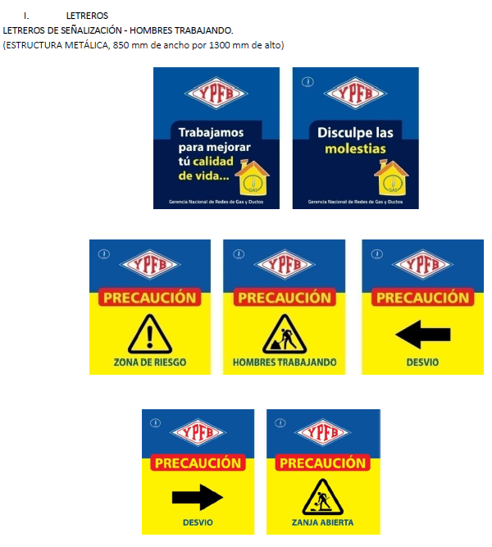

|

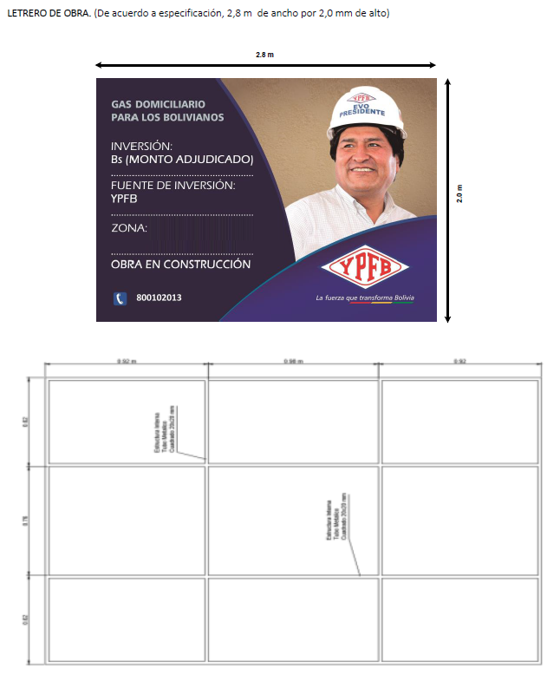

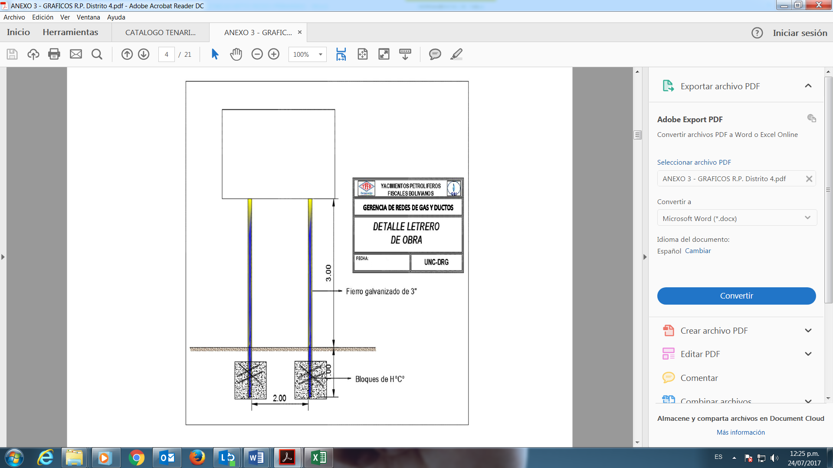

|  |  |
| --- | --- |
| **DETALLE** | **DATO** |
| Municipio | ORURO – LA JOYA |
| Distrito | 4,6 |
| OTB |  |
|  | |