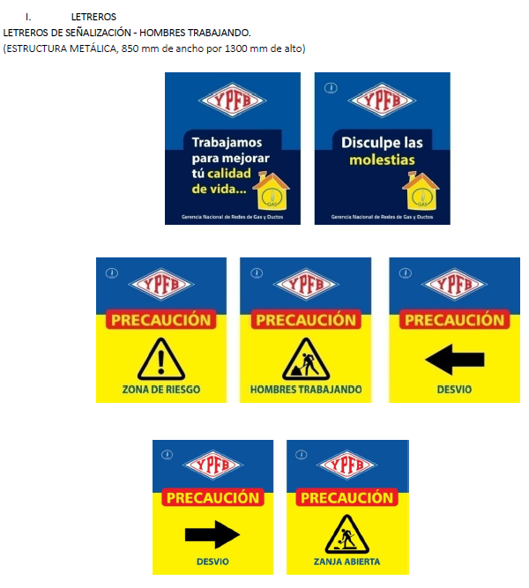

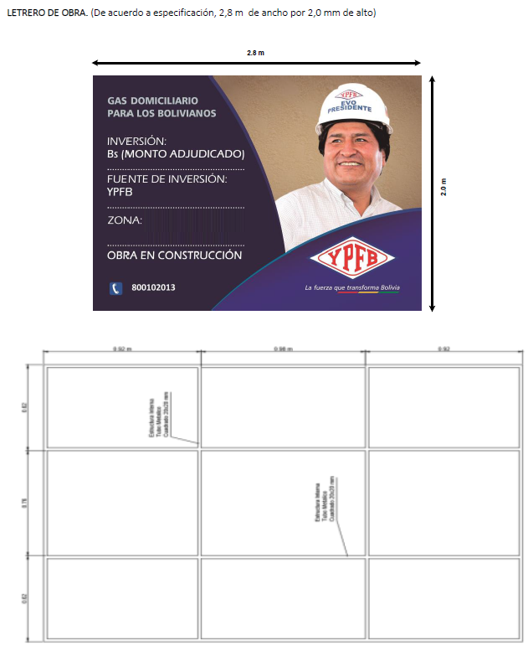

|  |  |
| --- | --- |
| **DETALLE** | **DATO** |
| Municipio | ORURO |
| Distrito | 1,2,3,4,5 |
| OTB | ORURO |
|  | |

|  |  |
| --- | --- |
| **DETALLE** | **DATO** |
| Municipio | PANDURO-EUCALIPTUS |
| Distrito | AREA RURAL |
| OTB | PANDURO-EUCALIPTUS |
|  | |

**Oruro, 12 de SEPTIEMBRE 2019**